Dear Students,
We are thrilled to congratulate each and every one of you on completing the Data Science course! Throughout this journey, you've shown dedication, perseverance, and a strong commitment to mastering essential skills in data analysis, visualisation, SQL, machine learning, and more.
As you prepare for your final evaluation (Project + Viva), we are confident that you are well-equipped to showcase your knowledge and skills. This evaluation will be a culmination of your hard work and learning achievements over the course duration.

Final Evaluation Details
- Duration: 12 days
- Submission Deadline: 28th September 2025, 11:59PM

Evaluation Questions
You can access the evaluation questions via this link. Please review the questions carefully and ensure you understand the requirements for each task.

Marking Scheme
The evaluation consists of tasks from different subjects, each contributing to your overall score. Here is the breakdown:
Subject | Tasks | Marks per Task
Excel | Top Global 2000 Largest Companies 2024 Dataset | 50
SQL | Olympics Dataset | 100
Tableau | World Population Analysis Dataset | 50
Machine Learning | Hotel Booking Dataset | 100

Naming Convention
- Submission Zip File: You need to submit a zip file that should be named as [Full Name]_CuvetteDS
  - Example: Shristi Agarwal_CuvetteDS
- Folders inside the Zip File: Each folder within the zip file should be named using the format [Full Name]_[Subject].
  - Example: Shristi Agarwal_Excel
    - Task 1: Excel format
    - Task 2: Excel format
  - Example: Shristi Agarwal_SQL
    - Task 1: SQL format
  - Example: Shristi Agarwal_Tableau
    - Task 1: Tableau workbook format
    - Task 2: Tableau workbook format
  - Example: Shristi Agarwal_Machine Learning
    - Task 1: Jupyter Notebook (source file)

Example
For example, if your name is Shristi Agarwal, your submission structure should look like this:
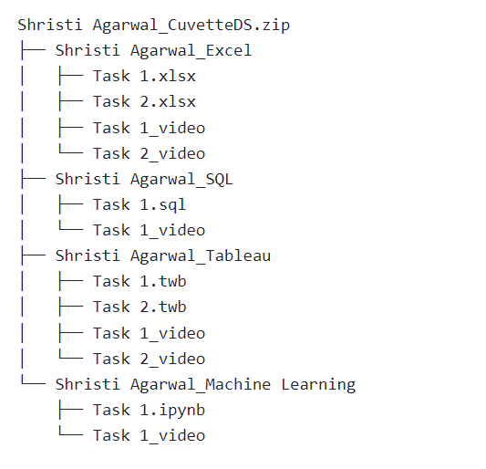

Tableau File Guidelines:

Set the data source connection as Extract first.

Go to File -> Export Packaged Workbook.

Submission Details
- Submission Format: Submit a zip file containing the above folders via the provided Google Form link.
- Apart from the above task files, you are required to submit videos explaining your solution for each task. You need to share your screen and make your face visible when you record the submission videos. Each video should be of max 5 mins duration. There must be a separate video for each Task provided.
- Submitting the zip file & video both are mandatory for the evaluation process.
- Technical help will not be provided for the evaluation tasks.
- If you need clarification on any task, you can chat with us from your learning dashboard.

Evaluation Guidelines
- Marking Scheme: Your submissions will be graded based on accuracy, completeness, clarity of presentation, and adherence to the given tasks.
- Plagiarism Policy: Plagiarism or unauthorised collaboration will result in disqualification from the evaluation process.
Please ensure you adhere to the deadlines and guidelines provided.

